Oscar Lopez
CS 443 M/W
12/03/24

Lab 6
- Draw the optimization tree for the following query.
SELECT Order_Num, Amount, Company, Name, City
FROM Orders, Customers, Salesreps, Offices
WHERE Cust = Cust_Num
AND Cust_Rep = Empl_Num
AND Rep_Office = Office
AND Amount > 20000

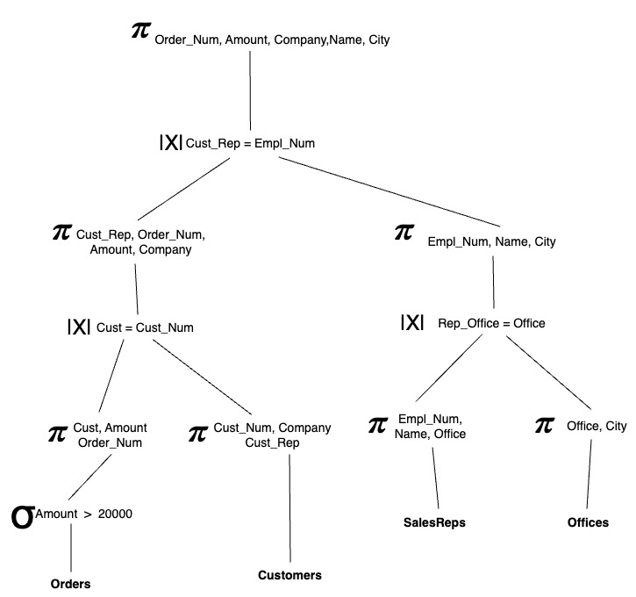
- Draw the optimization tree for the following query.
SELECT cust_num, cust_rep, name, rep_office, city
FROM Customers, Salesreps, Offices
WHERE empl_num = cust_rep, and rep_office = office
AND credit_limit >= 7000
And region = “western”
And office in (12, 13)

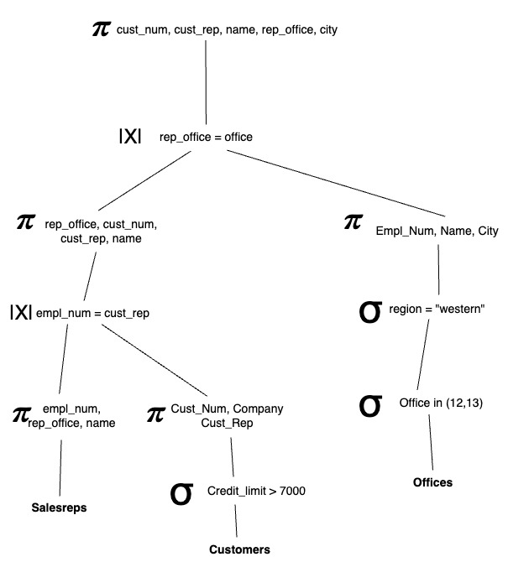

- Some of frequent attacks on the database include Unauthorized Privilege Escalation, Privilege Abuse, Denial of Service, and Weak authentication. Explain Privilege Abuse and weak Authentication is a few lines. (Slide 2)

Privilege Abuse: Authorized users misuse their privileges to perform malicious actions, such as a database administrator intentionally changing a student's grade.
Weak Authentication: Weak login credentials allow attackers to impersonate legitimate users, leading to unauthorized access.

- One form of Security Injection Attack is called “SQL manipulation”. Suppose we have the following query
SELECT *
FROM users
WHERE username = 'user_input' AND password = 'password_input’;
How can an attacker insert a code in the above query to retrieve the database data without authorization? (Slide 4)
SELECT *
FROM users
WHERE username = '' OR '1'='1' AND password = '' OR '1'='1’;

- Rewrite the following query with a php code to prevent the attack (Slide 6)

SELECT *
FROM users
WHERE username = 'user_input' AND password = 'password_input’;

- What are the four types of “Code Injection”? Just name them (no need to explain them).(Slide 7)

- SQL Injection
- Command Injection
- Script Injection
- BufferOverflow
- Provide examples of “Function Call Injection” where an attacker
  - can find the user id of a database user. Just provide the query. (Slide 14)
  - can find the version of database. Just provide the query. (Slide 15)
  - can find the currently connected database. (Slide 16)
  - can drop a table in the database. (Slide 17)

- SELECT * FROM employees WHERE first_name = '' OR 1=1; SELECT user() --';
- SELECT * FROM employees WHERE first_name = '' OR 1=1; SELECT version() --’;
- SELECT * FROM employees WHERE first_name = '' OR 1=1; SELECT database() --’;
- SELECT * FROM employees WHERE first_name = '' OR 1=1; EXEC xp_cmdshell('DROP TABLE employees') --;

- How to prevent the Function call Injection? Give a PHP code with pdoPrepare function that blocks attacker from function call injection. (Slide 19)

$stmt = $pdo->prepare("SELECT * FROM employees WHERE first_name = :first_name");
$stmt->execute(['first_name' => $user_input]);

- What are the typical risks associated with SQL Injection. Just name them, no need to provide any explanation. (Slides 20, and 21)

- Database Fingerprinting
- Denial of Service
- Bybass Authentication
- Identifying Injectable Parameters
- Executing Remote Commands
- Performing Privilage Escelation

- What are the three forms of protections against SQL Injection. Give example queries of each method. (Slide 22, 23, and 26)
- Bind variables or parameters
PreparedStatement stmtconn_PrepareStatement
(Select * FROM EMPLOYEE
WHERE EMPLOYEE_ID=? AND PASSWORD=?”);
Stmt.setString1.employee_id;
Stmt.setString2.password;
- Filter input(Input Validation)

input_username_escaped = input_username.replace("'", "‘’”)

- Function Security
cursor.execute("SELECT * FROM users WHERE username = ?", (user_input,))

